|  |  |  |  |  |  |  |
| --- | --- | --- | --- | --- | --- | --- |
| **Mehran University of Engineering & Technology,**  **Jamshoro** | |  | **Subject** | | | |
| **Web Technology** | | | |
| **Department of:**  **Bachelor of Science Computer Science** | | **Year** | **2nd** | **Semester** | **3rd** |
| **Roll No:** | **20BSCS043** | **Batch** | **20BSCS** | **Duration** | **3 Hours** |

**PRACTICAL # 2**

**TO MAKE USE OF VARIOUS TAGS RELATED WITH TABLES**

**Task # 1:** Make a 4x4 table, as sample given below;

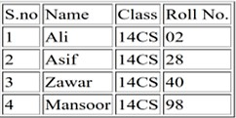

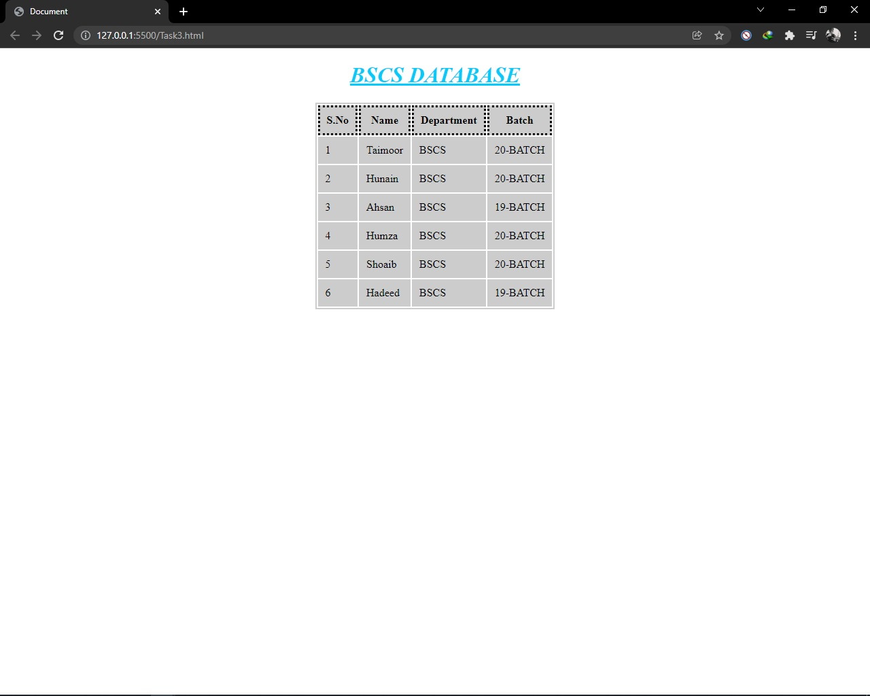

**Task 2:** Make a mark sheet pattern, as sample given below;

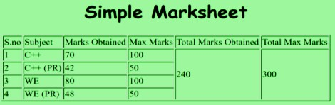

**Task # 3**: Highlight the few cells of table, as sample given below;

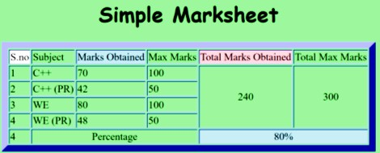

**Task # 4**: Apply various types of lists, sample given below;

